SUBJECT NAME
Software Engineering
GROUP NUMBER – GL 01
STUDY TYPE – Security and Continuity of IT
STUDENT ID NUMBER
65981
FIRST AND LAST NAME
Rasul Eminli

Online Ticketing System Report

Introduction
The purpose of this project is to design and analyze an Online Ticketing System that allows customers to reserve and purchase tickets for events such as concerts, theater performances, and sports matches. The system supports both individual ticket purchases and season pass subscriptions while maintaining security, scalability, and usability.
The platform operates continuously and enables customers to access ticketing services regardless of ticket office operating hours. The system additionally supports administrative management, event maintenance, customer support, and payment processing.

Project Objectives
The primary objectives of the system are:
- Provide online reservation and ticket purchasing
- Support season pass subscriptions
- Allow event searching and browsing
- Manage ticket availability automatically
- Support payment verification
- Provide customer notifications
- Maintain secure access control
- Support administrators and staff management

System Requirements

Functional Requirements
The system shall:
- Allow customers to register accounts
- Allow customers to log in securely
- Display event information
- Allow searching events using filters
- Support ticket reservation
- Support ticket purchasing
- Support season pass subscriptions
- Verify payments
- Send reservation confirmations
- Automatically expire reservations
- Apply penalties when required
- Allow staff to manage events and ticket inventory
- Allow administrators to configure system settings

Non-Functional Requirements
The system should provide:
- Continuous availability
- Secure authentication
- Automatic logout after inactivity
- Fast response times
- Data integrity
- Scalability
- Reliability

Actors
The system includes the following actors:

Customer
- Registers accounts
- Searches events
- Reserves tickets
- Purchases tickets
- Purchases subscriptions

Staff Member
- Adds events
- Manages ticket inventory
- Processes refunds
- Supports customers

Administrator
- Manages staff accounts
- Configures system parameters
- Maintains system security

Payment System
- Verifies payments

System Analysis
The reservation process begins when customers authenticate and browse available events. Customers may choose either individual tickets or season subscriptions.
The system verifies availability and user restrictions before creating reservations. Reservations are temporarily held and require confirmation within a specified timeframe.
When payment succeeds, tickets or subscriptions are activated. If reservations expire or payment fails, resources return to available inventory.

BPMN Analysis
The BPMN model describes:
- Login and registration
- Event search
- Reservation process
- Ticket availability verification
- Reservation holding
- Payment processing
- Reservation expiration
- Notification handling
- Ticket generation
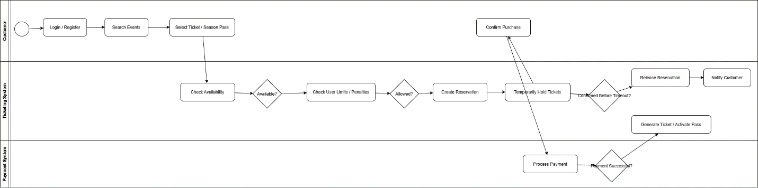

Use Case Analysis
Major use cases include:
- Register User
- Login
- Search Events
- Reserve Tickets
- Purchase Tickets
- Purchase Season Pass
- Add Events
- Manage Inventory
- Process Refunds
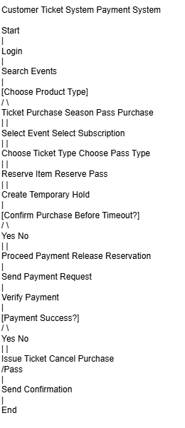

Domain Model
The domain model contains:
- Users
- Customers
- Events
- Reservations
- Tickets
- Ticket Types
- Payments
- Season Passes
Relationships between these entities allow reservation and purchasing operations to function correctly.
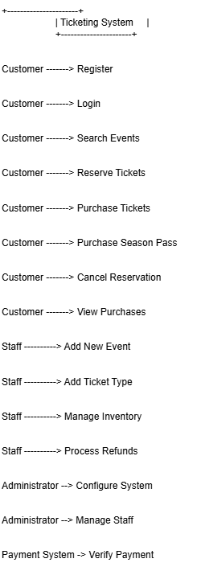

Sequence Analysis
The sequence diagram demonstrates communication between:
- Customer
- Ticketing System
- Database
- Payment System
The sequence covers searching events, reservation creation, payment processing, and ticket generation.
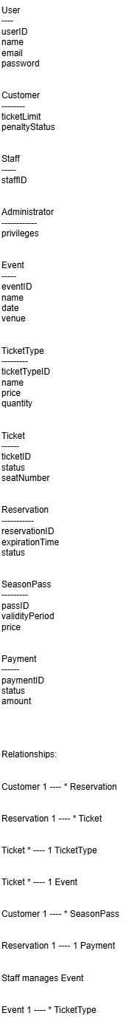

Testing
Unit testing was performed using the Celsius to Fahrenheit conversion function.
Example function:
def celsius_to_fahrenheit(c):
return (c * 9/5) + 32
The following test cases were executed:
Celsius | Expected Fahrenheit
0 | 32
100 | 212
-40 | -40
25 | 77
36.6 | 97.88
1000 | 1832
All tests passed successfully.

GitHub Version Control
Git was used to manage project versions.
Typical workflow:
- Initialize repository
- Add files
- Commit changes
- Push to GitHub repository
Version control provides:
- Backup
- Collaboration support
- Change tracking
- Project history
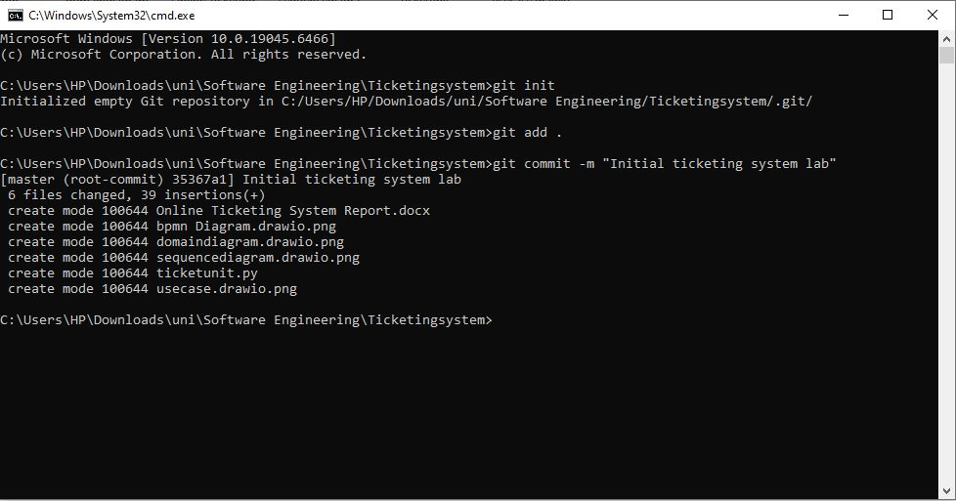
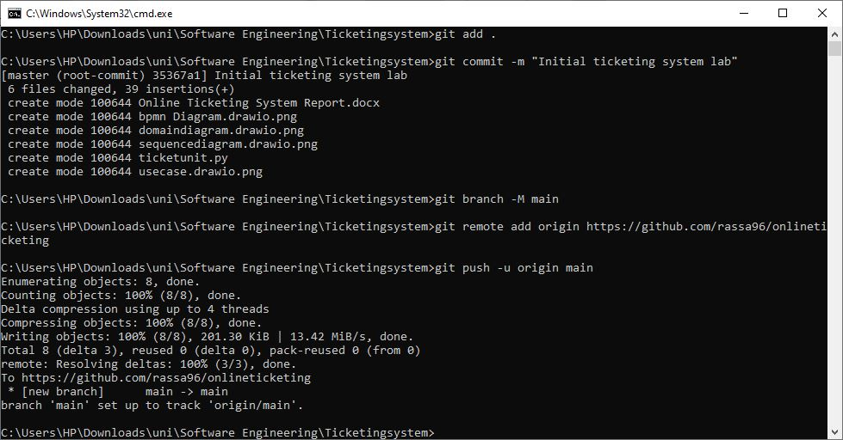

Conclusion
The Online Ticketing System provides an effective platform for managing event reservations and ticket purchases. The design supports both occasional customers and regular subscribers while maintaining security, availability, and scalability.
The use of BPMN, UML diagrams, testing procedures, and Git version control demonstrates the application of Software Engineering principles during system analysis and design.

